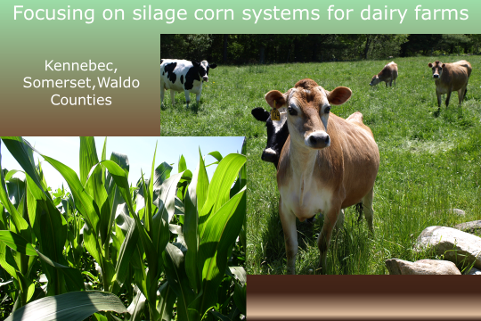
Improving Soil Health through Cover Cropping and Reduced Tillage in the Dairy Belt of Maine

Project summary:
In 2014, the Kennebec, Somerset and Waldo County Soil and Water Conservation Districts partnered together with the University of Maine Cooperative Extension to help dairy producers in Kennebec, Somerset, and Waldo counties improve soil health on their farms through the use of cover crops and no-till planting, both proven soil health conservation practices. The project provided financial and technical assistance to innovatively implement these practices at a reduced financial risk to the farmer.

Why cover crop and no-till? The increase in soil quality increases the viability and resiliency of the farming operation, reduces the need for chemical inputs, and helps farmers establish a sustainable silage corn cropping system to provide quality long-term forage for their livestock.

An increase in soil quality benefits not only the farming operations, but also Maine’s natural resources and public. Better soil health provides more sustainable and better quality crops and forages, improving the whole ecosystem of the area. Keeping cover on the soil throughout the year helps reduce erosion, nutrient leaching, and phosphorus loading to sensitive lake watersheds.
“Trying no till on long-standing corn ground made me realize how compacted the ground gets when it is in conventional corn year after year.”
Nick Chambers, FourthGen Farms, Saint Albans

The goals of the project were twofold: The first and primary goal was to help farmers in each of the three counties continue or get started on their own soil health improvement plan. We worked with a total of 16 farms from the three counties. These included farms that were taking their first step towards soil health practices, as well as other farms that were looking to add diversity to their cover crop mixes or add additional practices to their existing soil health protocol. The project included EQIP-eligible farms in each of the three counties, and involved a variety of soil types.

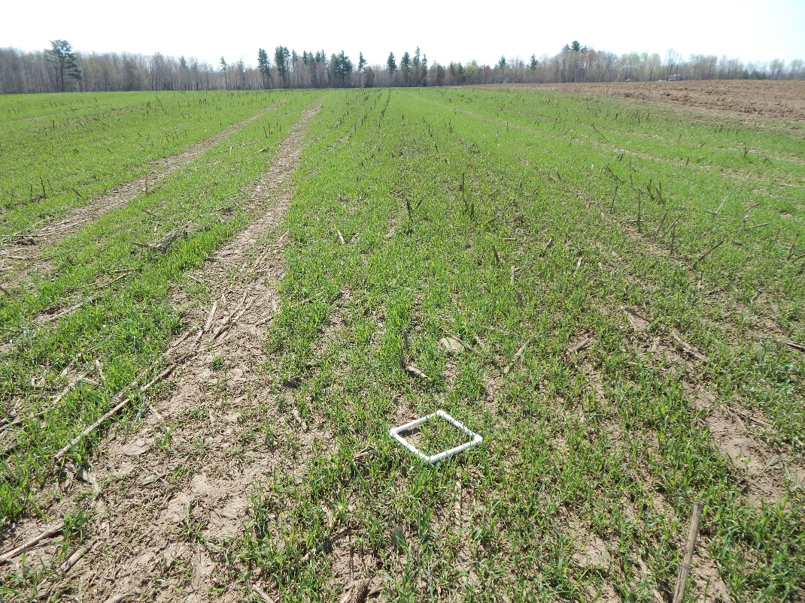
The second project goal was to continue to gather data and information to demonstrate and quantify the soil health benefits of cover crops and reduced/no-till planting. This was done using a side-by-side comparison of a “split field” where small acreages with the same soil types and other similar properties were split. Half of the field was sown with a winter hardy cover crop in the fall and half was left fallow. Soil, crop, and yield analysis was conducted by University of Maine Cooperative Extension Educators on participating farm fields. In addition to standard soil nutrient testing, the split-field soils were tested using the University of Maine soil testing package. This includes measuring water-stable aggregates, CO₂ burst (for active carbon and microbial biomass carbon), and potentially mineralizable nitrogen.
Measuring spring-time cover crop density and vigor

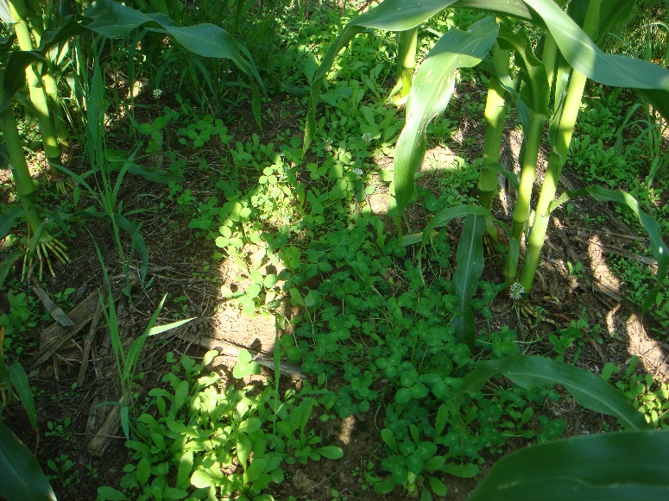
The process:
Inter-seeded multi-species cover crop germination, July
Establishing cover crops in silage corn systems is something many producers feel is important for reducing erosion and improving soil and crop health. In 2014, we worked entirely with participants to fall sow a winter hardy cover crop. We also did this with some of our farmers in 2015. The major finding with this tactic was that despite the very different weather pattern in fall of 2014 and 2015, farmers had a difficult time both years getting the fall-sown cover crops established. The fall window after harvest was extremely tight, and the outlay of cash and labor resources at that time of year was difficult for farmers. The increasing unpredictability of the weather that time of year compounds the problem.

Inter-seeding trials: Inter-seeding is a practice that is being promoted in other parts of New England. Farmers in our program agreed that inter-seeding the cover crop into standing corn would help to overcome many of the management barriers to cover crop installation. Thus, starting in 2015 and continuing for 2016 and 2017, we worked with several farmers on inter-seeding trials; planting the winter cover crop during the growing season, before the corn was harvested. This timing avoids many of the management challenges for the farms.

Many farmers expressed an interest in trying to inter-seed cover crops with their summer nitrogen applications. This practice is attractive to many producers because it is the simplest, lowest-cost option and does not require any extra trips to the fields and no soil incorporation of the seed. Thus, it fits in well with current farm management practices and resources. In 2015 and 2016, we worked with NorthEast Ag and Certified Crop Advisors to come up with seeding mixes and methods for adding cover crop seed to urea applications. Unfortunately, these trials could not produce reliable success rates for cover crop establishment. Even so, farmers still have an interest in trying to make this work.
“I would really like to add winter cover cropping to the farm management. I think getting the inter-seeding procedure down to be successful is the key.” Dan Mantor, Mantor Farm, Madison

Though our CIG program has ended, we would like to see research continue to see if the protocol for this inter-seeding method could be improved to make it a viable practice to recommend for farmers.

The other innovation being tested in 2016 was the use of a plane for aerial inter-seeding. These trials were much more successful and resulted in uniform and dense cover by winter snows.

Choosing the highest priority project goal: As we got into the project and recruited farmers to the program, we found that we were going to have to identify the primary of the two project goals, as on more than one occasion, the two goals came into conflict with one another. We unanimously decided that moving producers along in their soil health journey was of greatest importance. Throughout the course of the project, some farmers got so excited about cover cropping that they seeded their entire “split field”, or implemented an inter-seeding or no till practice on their split field. This compromised the research goal of the split field protocol, but we took it as assurance that farmers were enthusiastic about making advances in their soil health management.

Challenges:
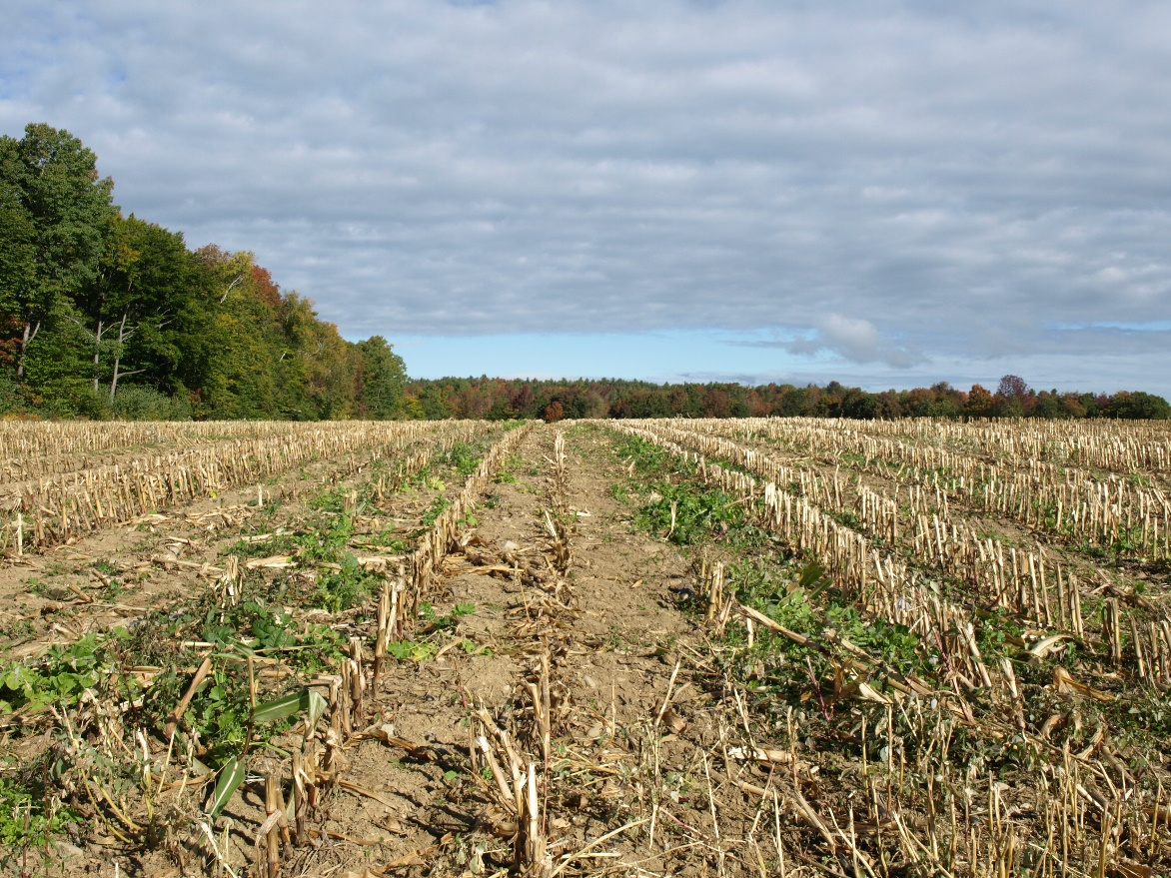
There were several challenges we faced while working on this project. The first challenge was the barriers (timing, labor and cash availability) that made it difficult to establish winter cover crops in the fall after corn harvest. Another challenge was in the logistics of trying to do multi-year study on the same field plots. We realized after the end of the second year that we should have had an added incentive for farmers to comply during the second year. Many plots were inadvertently taken out of the program because some farmers, despite reminders, neglected to keep the split lines true for the second year. In 2014, we also had a challenge getting enough winter rye seed for the program. Cost and seed quality were also issues for that year. During the following years of the program, farmers were encouraged to seek seed sources earlier and those issues were less prevalent. With our inter-seeding with summer nitrogen application trials, challenges included herbicide residue, thickness and height of corn at inter-seeding, and inadequate seed to soil contact (See photo above: seed catch was mainly in wheel tracks).
Inter-seeding cover crop catch in wheel tracks

Timeline:
Fall 2014: Project kickoff and farmer recruitment; farmer fall split field winter cover establishment; begin outreach activities; research data collection begins
2015: First no-till field trials, first inter-seeding trials, more fall winter cover establishment; split field trial continuation; farmer recruitment continuation, more outreach activities
2016: Continued no-till trials on new farms, adjustments made to N application inter-seeding protocol, aerial inter-seeding trials, split field continuation, outreach
2017: High boy/inter-seeder now available through Northeast Ag – trialed at Somerset County producer fields

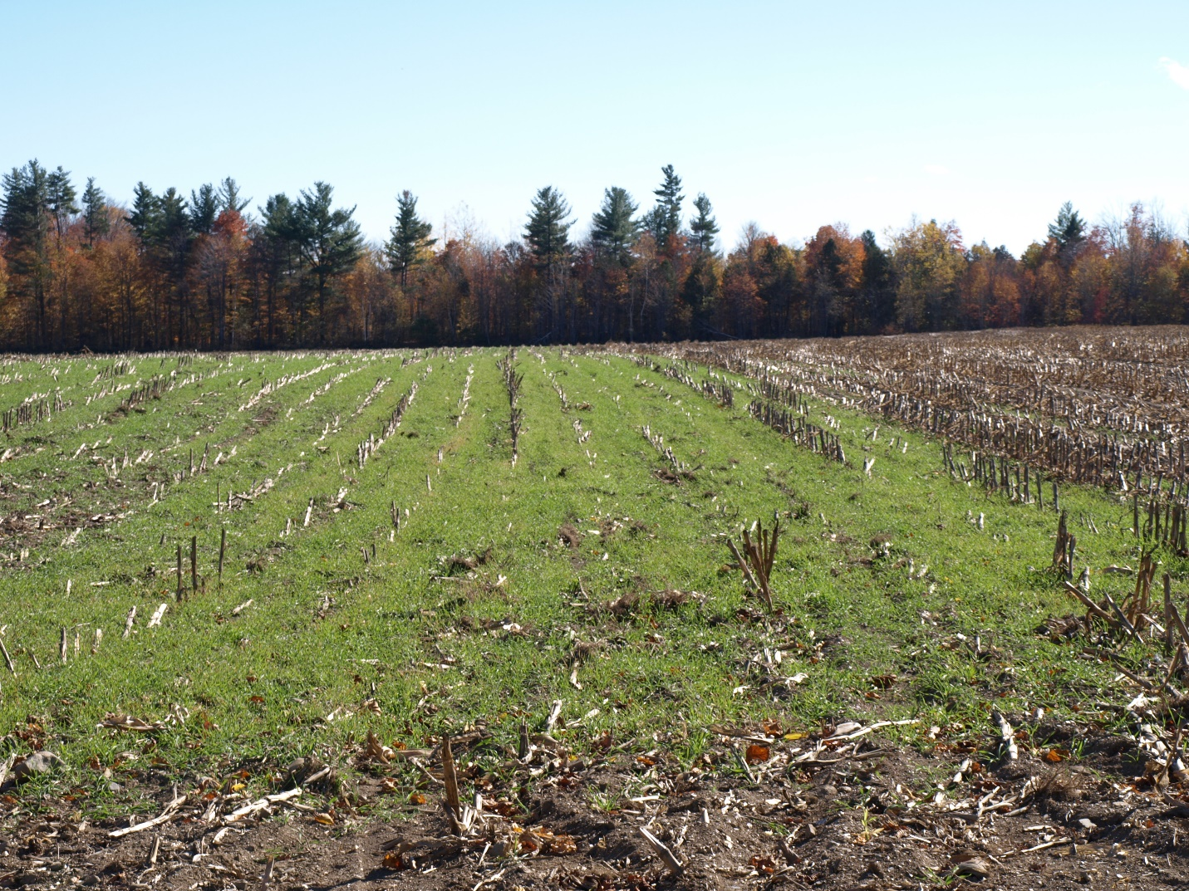
Impacts and Results:

F First-time winter cover on “split-field” trial in Saint Albans
- Farmers in each of the three counties participated in the program.
- Among program participants, there was adoption of soil health practices and significantly increased soil health management during timeframe of the project.
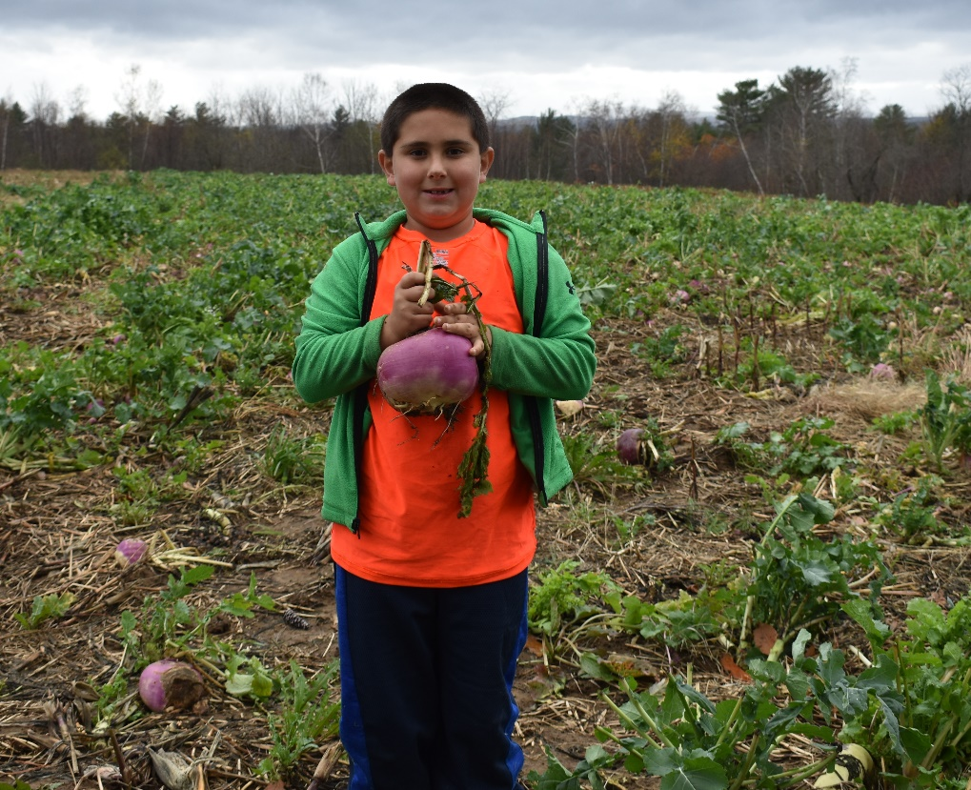
- We were able to partner with other concurrent soil health initiatives during the project timeframe which worked to increase the scope of influence and impacts of the program. Several farms found no-till to be effective on their farms – at least three producers purchased no-till drills during project timeframe.
Ti Jacolby Paine with Inter-seeded turnip on Paine Farm in Madison
- Most of the farmers planted many more acres to both no till and cover crop than they were being reimbursed for, showing a commitment to the practices for their own benefit
- Some of our producers became ambassadors for the soil health movement, talking with neighboring producers about their results and making suggestions.
- Several program participants had successful EQIP applications for continuing cover crop practices.
- In an area where there are many continuous corn fields year after year, crop rotation, though it was not specifically paid for through this grant, is another key soil health practice. Some of the producers that were frustrated with the difficulty of establishing viable cover crops with current management practices, found that implementing a crop rotation schedule worked very well for them, especially in conjunction with no-till planting. As a result of adding crop rotation and no-till together, farmers felt they received an improvement in soil tilth and decrease in compaction on fields.

In summary, over the duration of the project our 16 CIG producers (7 in Somerset, 3 in Waldo, and 6 in Kennebec Counties) logged over 900 acres of winter cover (including inter-seeded crops and multi-species) and over 700 acres of new no till silage corn production. There was significantly increased awareness of the importance and understanding of soil health practices across the three county area.
“I really saw a difference in our no-till ground when we had heavy rains. I could still get on that ground when the other corn ground was ‘mush’.”
Joel Taylor, Taylor Dairy Farm, Saint Albans

The products:
- Videos:
https://extension.umaine.edu/agriculture/soil-health/no-till-and-reduced-tillage/

- Farmer profiles: See link above for Stoneyvale Farm case study and below for Tim Hewett Farmer Profile
- Farmer Surveys: See below for Ingraham, Keene and Kennebec Surveys
- Soil loss, P modeling for split fields (Separate file)
- Split field research results (Separate file)
- No-till Tip Sheet:
- Cover Crop Tip Sheet:
- Producer Information Document:
- Soil Health Page on SCSWCD website (http://somersetswcd.org/soil-health/)
- List of presentations and outreach:

Looking ahead: Remaining challenges and recommendations

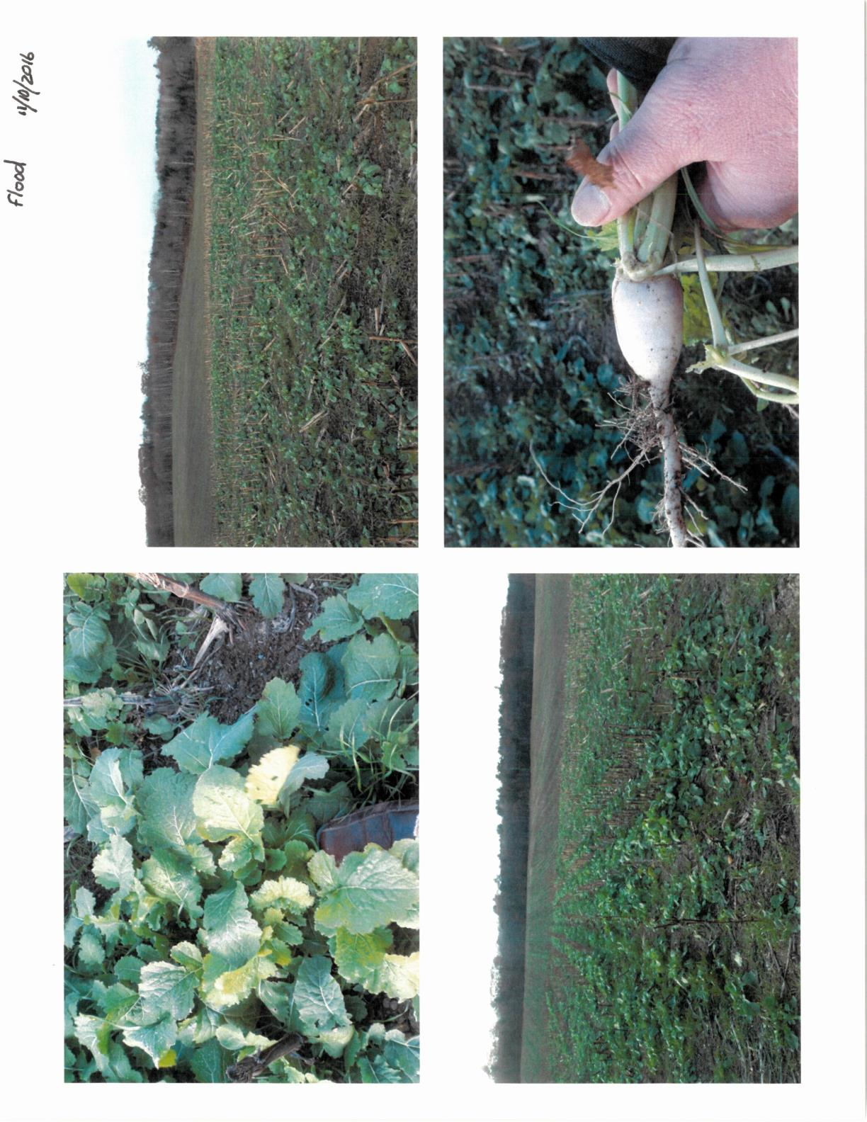
Cover cropping for 2018 and beyond: Aerial seeding, particularly with a plane, seemed to be successful in our 2016 and 2017 trials, and drop-tube inter-seeding trials (to allow the seed to be placed on the ground between corn rows) showed promise. Many of our farmers as well as the steering committee for this project would like to see more trials with both methods to discover if results will be consistent across years and different farming operations and situations. Given feedback from participating farmers, we would also like to see possible further attempts to update a protocol for adding seed to summer N applications. This is still of interest to many farmers, as it represents a cost-effective and easy way to implement the practice. Perhaps research could find further modifications that could be made to make this an effective practice.
Kennebec County field inter-seeded by plane in August 2016

No-till corn planting: No-till seems to be less fraught with challenges, and those who have done initial trials are continuing to slowly build the number of acres planted this way, citing less use of fuel and time as benefits.
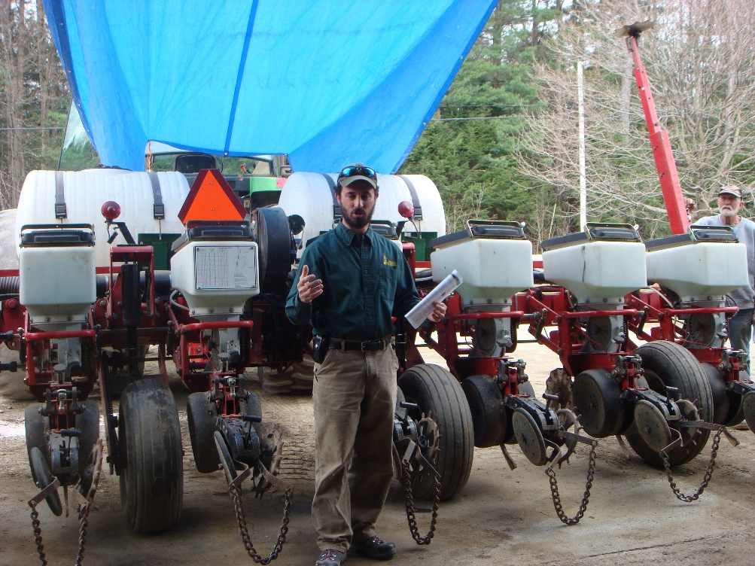
No-till Planter Tune-Up Workshop, Hewett Farm, Skowhegan
In summary, having cover on the fields year round and growing crops in the early spring brings many benefits! It is worth the trouble shooting that farmers are going through to make winter cover application work on their farms. No-till planting provides additional soil health benefits. This CIG project has helped dairy producers in Kennebec, Somerset and Waldo Counties improve soil quality on their farms. Implementation of a combination of cover cropping, no-till and/or crop rotation results in improved moisture control, reduced fertility input needs and improved soil and feed quality. These practices not only benefit the farms themselves, but also the water quality in local lakes, rivers and streams. In a future of changing climate and other challenges, we need sustainability and resiliency in our crops. As our program participants have discovered, these practices are a great place to start.
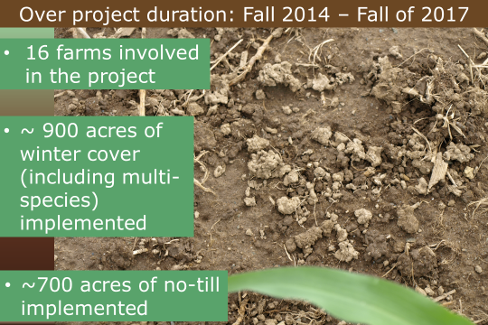
E Earthworm castings on soil surface

